22. Cascading Dropdown
First create the required tables and populate them, with some sample data using the SQL script below.
Create Table tblContinents
(
ContinentId int identity primary key,
ContinentName nvarchar(50)
)
Insert into tblContinents values ('Asia')
Insert into tblContinents values ('Europe')
Insert into tblContinents values ('South America')
Create Table tblCountries
(
CountryId int identity primary key,
CountryName nvarchar(50),
ContinentId int foreign key references dbo.tblContinents(ContinentId)
)
Insert into tblCountries values ('India', 1)
Insert into tblCountries values ('Japan', 1)
Insert into tblCountries values ('Malaysia', 1)
Insert into tblCountries values ('United Kingdom', 2)
Insert into tblCountries values ('France', 2)
Insert into tblCountries values ('Germany', 2)
Insert into tblCountries values ('Argentina', 3)
Insert into tblCountries values ('Brazil', 3)
Insert into tblCountries values ('Colombia', 3)
Create Table tblCities
(
CityId int identity primary key,
CityName nvarchar(50),
CountryId int foreign key references dbo.tblCountries(CountryId)
)
Insert into tblCities values ('Bangalore', 1)
Insert into tblCities values ('Chennai', 1)
Insert into tblCities values ('Mumbai', 1)
Insert into tblCities values ('Tokyo', 2)
Insert into tblCities values ('Hiroshima', 2)
Insert into tblCities values ('Saku', 2)
Insert into tblCities values ('Kuala Lumpur', 3)
Insert into tblCities values ('Ipoh', 3)
Insert into tblCities values ('Tawau', 3)
Insert into tblCities values ('London', 4)
Insert into tblCities values ('Manchester', 4)
Insert into tblCities values ('Birmingham', 4)
Insert into tblCities values ('Paris', 5)
Insert into tblCities values ('Cannes', 5)
Insert into tblCities values ('Nice', 5)
Insert into tblCities values ('Frankfurt', 6)
Insert into tblCities values ('Eutin', 6)
Insert into tblCities values ('Alsfeld', 6)
Insert into tblCities values ('Rosario', 7)
Insert into tblCities values ('Salta', 7)
Insert into tblCities values ('Corrientes', 7)
Insert into tblCities values ('Rio de Janeiro', 8)
Insert into tblCities values ('Salvador', 8)
Insert into tblCities values ('Brasília', 8)
Insert into tblCities values ('Cali', 9)
Insert into tblCities values ('Montería', 9)
Insert into tblCities values ('Bello', 9)
Create procedure spGetContinents
as
Begin
Select ContinentId, ContinentName from tblContinents
End
Create procedure spGetCountriesByContinentId
@ContinentId int
as
Begin
Select CountryId, CountryName from tblCountries
where ContinentId = @ContinentId
End
Create procedure spGetCitiesByCountryId
@CountryId int
as
Begin
Select CityId, CityName from tblCities
where CountryId = @CountryId
End

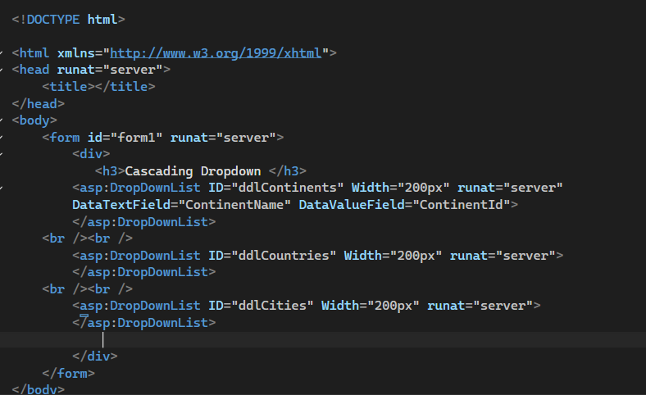
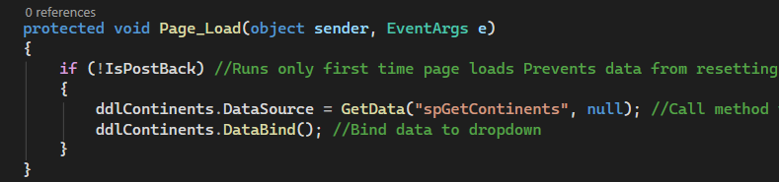
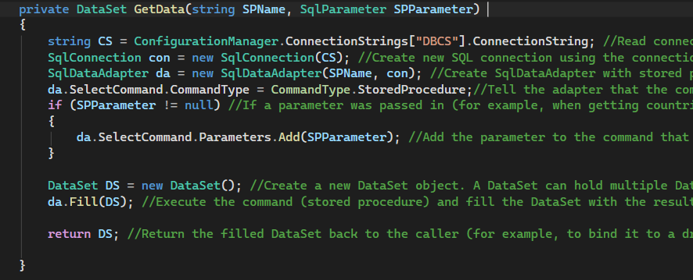
Output
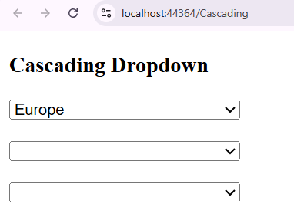
Output -- the web page will show Select Continent after page load
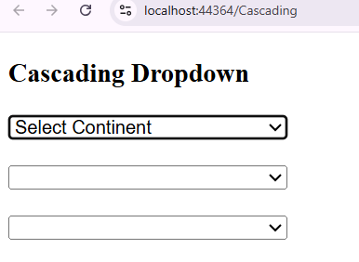
Same method for another dropdown
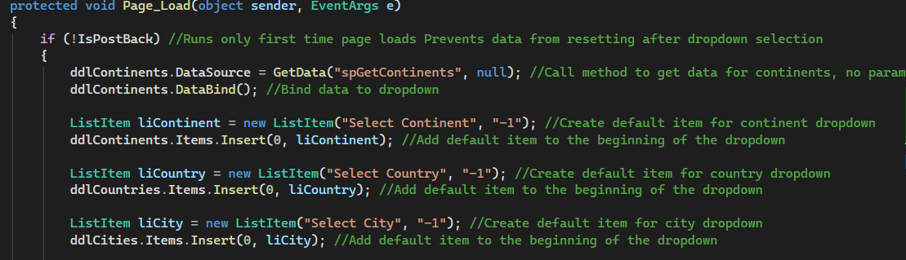
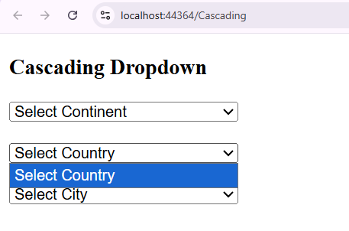
We have to disable the dropdown 2 and 3 when page load
Output will be
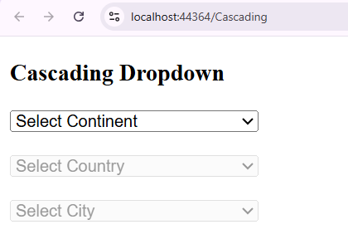
Now if we select the first dropdown then dropdown should be enabled

Html have DataTextField and DataValueField

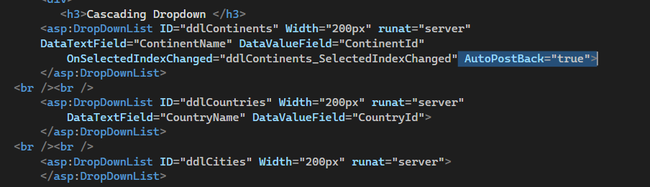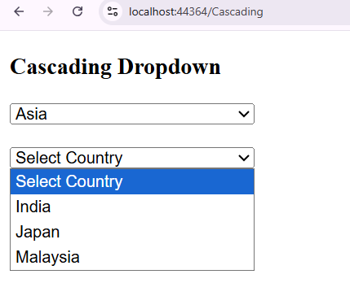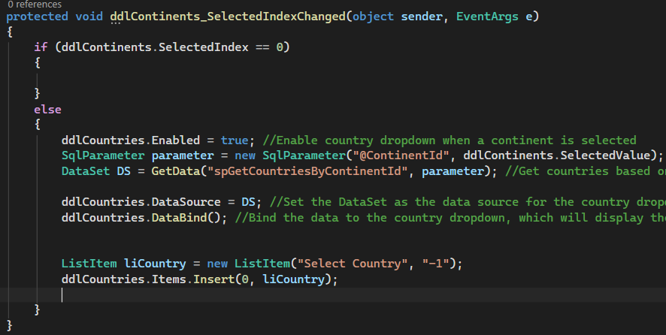
Same system will apply on cities list If country name event clicks then cities name pop up
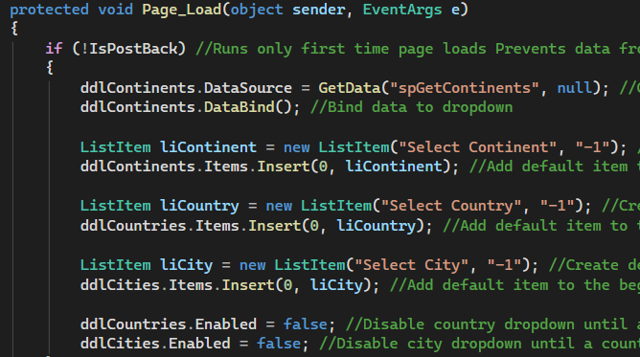
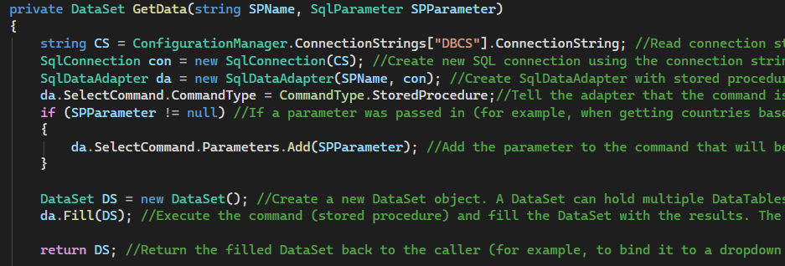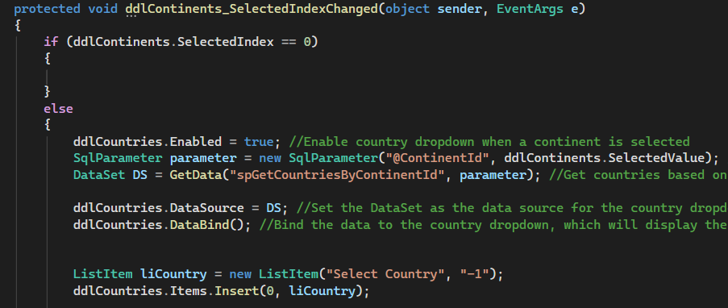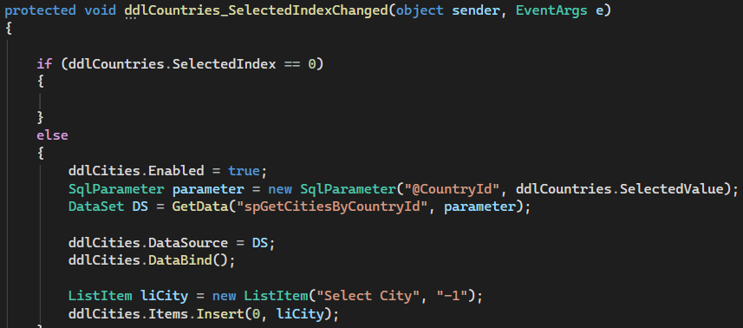
Disable cities until county is selected
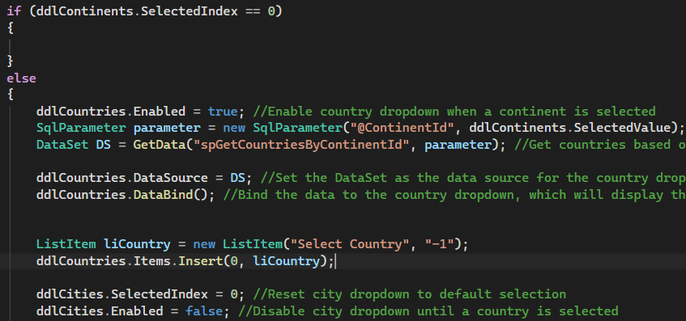
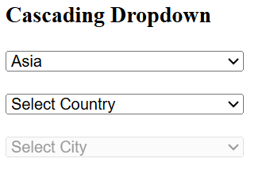
Disable country until continent selection
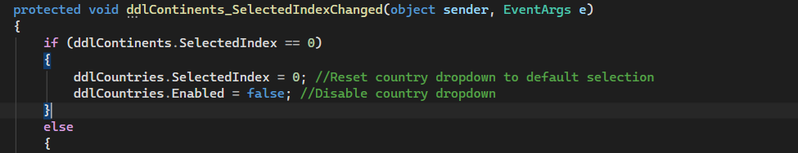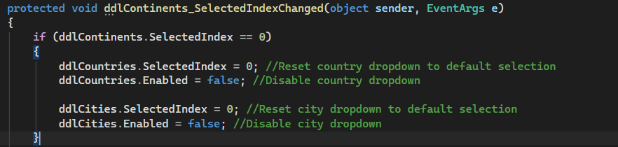
Output
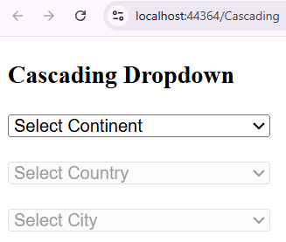
But problem is when select continent the value of city not reset
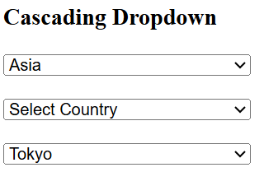
Adding method
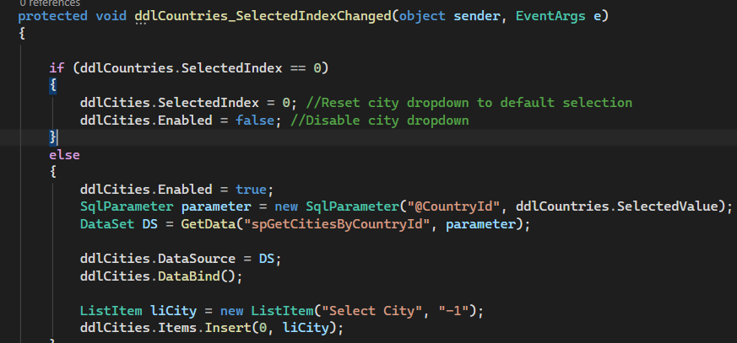
Now output
